**EXPT NO: 9A A python program to implement**

**DATE: 25.10.2024 KNN MODEL .**

# AIM:

TowriteapythonprogramtoimplementKNNModel.

# PROCEDURE:

ImplementingKNNModelusingthemall_customerdatasetinvolvethefollowing steps:

**Step1:ImportNecessaryLibraries**

First,importthelibrariesthatareessentialfordatamanipulation,visualization,and model building.

import numpy as np

importmatplotlib.pyplotasplt import pandas as pd

fromsklearn.model_selectionimporttrain_test_split from sklearn.preprocessing import StandardScaler

from sklearn.neighbors import KNeighborsClassifier

fromsklearn.metricsimportclassification_report,confusion_matrix from sklearn.cluster import KMeans

**Step2:LoadtheDataset**

Themall_customerdatasetcanbeloadedanddisplaythefirstfewrowsofthedataset.

# Load the dataset

dataset = pd.read_csv('/content/Mall_Customers.csv')

#Displaythefirstfewrowsofthedataset print(dataset.head())

# Display the dimensions of the dataset print(f"Datasetshape:{dataset.shape}")

#Displaydescriptivestatisticsofthedataset print(dataset.describe())

**Step3:Separatethefeatures(x)andtargetvariable (y)**

# Separate the features (X) and the target variable (y)

X = dataset.iloc[:, [3, 4]].values #Weuse'AnnualIncome'and'Spending Score'

#Standardizethefeatures scaler = StandardScaler()

X_scaled = scaler.fit_transform(X)

**Step4:Visualizingtheclusterofcustomer**

#ApplyKMeansclusteringusingtheElbowMethodtofindtheoptimalnumber of clusters

wcss = [] #Within-clustersumofsquares for i in range(1, 11):

kmeans=KMeans(n_clusters=i,init='k-means++',max_iter=300,n_init=10, random_state=0)

|  |  |  |  |  |  |  |  |  |
| --- | --- | --- | --- | --- | --- | --- | --- | --- |
| **kmeans.fit(X_scaled) wcss.append(kmeans.inertia_)**  **# Plot the Elbow Method graph plt.plot(range(1, 11), wcss) plt.title('The Elbow Method') plt.xlabel('Numberofclusters') plt.ylabel('WCSS')**  **plt.show()**  **#Fromtheplot,wecanobservethattheoptimalnumberofclustersis5 (elbow point)**  **kmeans=KMeans(n_clusters=5,init='k-means++',max_iter=300,n_init=10, random_state=0)**  **y_kmeans = kmeans.fit_predict(X_scaled)**  **# Visualizing the clusters of customers** | | | | | | | | |
| **plt.scatter(X_scaled[y_kmeans c='red', label='Cluster 1')** | **==** | **0,** | **0],** | **X_scaled[y_kmeans** | **==** | **0,** | **1],** | **s=100,** |
| **plt.scatter(X_scaled[y_kmeans c='blue', label='Cluster 2')** | **==** | **1,** | **0],** | **X_scaled[y_kmeans** | **==** | **1,** | **1],** | **s=100,** |
| **plt.scatter(X_scaled[y_kmeans c='green', label='Cluster 3')** | **==** | **2,** | **0],** | **X_scaled[y_kmeans** | **==** | **2,** | **1],** | **s=100,** |
| **plt.scatter(X_scaled[y_kmeans c='cyan', label='Cluster 4')** | **==** | **3,** | **0],** | **X_scaled[y_kmeans** | **==** | **3,** | **1],** | **s=100,** |
| **plt.scatter(X_scaled[y_kmeans** | **==** | **4,** | **0],** | **X_scaled[y_kmeans** | **==** | **4,** | **1],** | **s=100,** |
| **c='magenta', label='Cluster 5')** | | | | | | | | |

# Plot the centroids

plt.scatter(kmeans.cluster_centers_[:,0],kmeans.cluster_centers_[:,1], s=300, c='yellow', label='Centroids')

plt.title('Clusters of customers') plt.xlabel('Annual Income (k$)') plt.ylabel('SpendingScore(1-100)') plt.legend()

plt.show()

# OUTPUT:

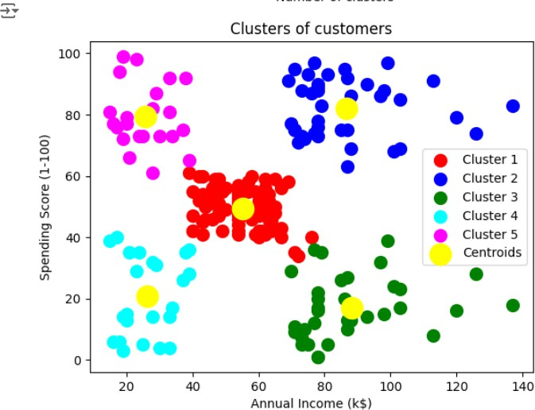

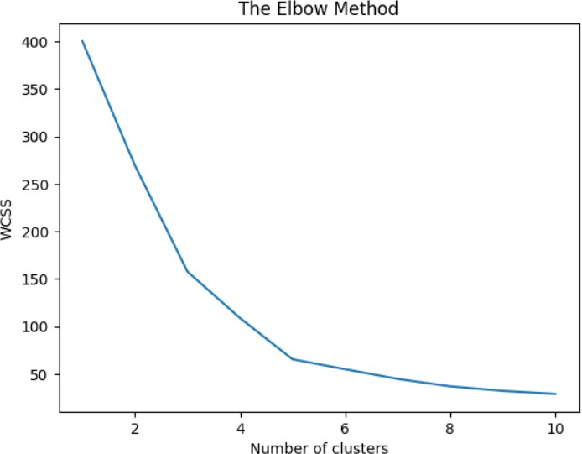

**RESULT:**

ThusthepythonprogramtoimplementKNNmodelhasbeensuccessfully implemented and the results have been verified.

**EXPT NO: 9B Apythonprogramtoimplement DATE: 25.10.2024 K-Means Model**

# AIM:

TowriteapythonprogramtoimplementtheK-meansModel.

# PROCEDURE:

ImplementingK-meansModelusingthemall_customerdatasetinvolvethe following steps:

**Step1:ImportNecessaryLibraries**

First,importthelibrariesthatareessentialfordatamanipulation,visualization,and model building.

import numpy as np importpandasaspd

from math import sqrt

**Step2:loadthe Dataset**

data = pd.read_csv('/content/Mall_Customers.csv')

data.head(5)

# OUTPUT:

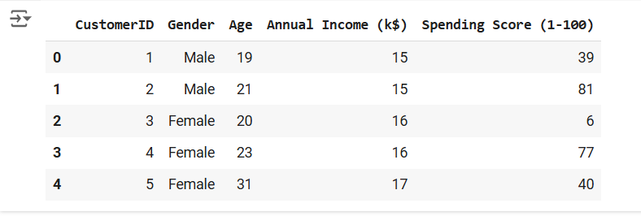

**Step3:Preprocessthedata**

req_data = data[['Age', 'Annual Income (k$)', 'Spending Score (1-100)']]

req_data.head(5)

# OUTPUT:

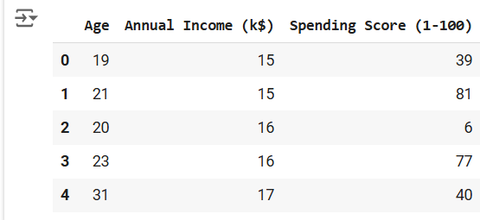

**Step4:Assignthedatapointstoclusters**

shuffle_index = np.random.permutation(req_data.shape[0]) #Shufflethe dataset rows

req_data = req_data.iloc[shuffle_index]

req_data.head(5)

# OUTPUT:

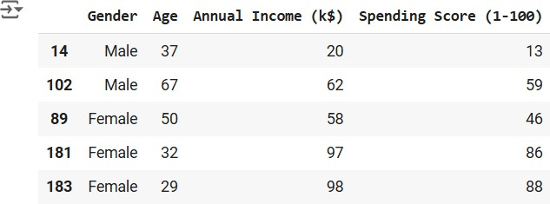

**Step5:Updatetheclusterscenters**

train_size = int(req_data.shape[0]*0.7) #Set70%ofthedatafortraining train_df = req_data.iloc[:train_size,:]

test_df = req_data.iloc[train_size:,:]

train = train_df.values #Converttraindatatonumpyarray test = test_df.values # Convert test data to numpy array y_true = test[:,-1] # The target values for the test set

print('Train_Shape:',train_df.shape) print('Test_Shape: ', test_df.shape)

from math import sqrt

defeuclidean_distance(x_test,x_train): distance = 0

for i in range(len(x_test)): #Loopthroughallfeatures distance += (x_test[i]-x_train[i])**2

return sqrt(distance)

defget_neighbors(x_test,x_train,num_neighbors): distances = []

data = []

for i in x_train: distances.append(euclidean_distance(x_test,i)) data.append(i)

distances = np.array(distances)

data = np.array(data)

sort_indexes = distances.argsort() #Sortdistancesinascendingorder data = data[sort_indexes] # Sort the data based on sorted distances

return data[:num_neighbors] #Returntheclosest'num_neighbors'neighbors

defprediction(x_test,x_train,num_neighbors): classes = []

neighbors=get_neighbors(x_test,x_train,num_neighbors) for i in neighbors:

classes.append(i[-1]) #The target value is the last column

predicted = max(classes, key=classes.count) #Returnthemostfrequent class (the majority vote)

return predicted

defpredict_classifier(x_test): classes = []

neighbors = get_neighbors(x_test, req_data.values, 5) #Predictusing the top 5 neighbors

for i in neighbors: classes.append(i[-1])

predicted = max(classes, key=classes.count) #Returnthemajorityvote print(predicted)

return predicted

defaccuracy(y_true,y_pred): num_correct = 0

for i in range(len(y_true)):

if y_true[i] == y_pred[i]: #Comparetruevaluestopredictedvalues num_correct += 1

accuracy = num_correct / len(y_true) #Calculateaccuracyastheratio of correct predictions

return accuracy

defaccuracy(y_true,y_pred): num_correct = 0

for i in range(len(y_true)):

ify_true[i]==y_pred[i]: num_correct += 1

returnnum_correct/len(y_true) y_pred = []

for i in test:

y_pred.append(prediction(i, train, 5)) #Makepredictionsforeachtest instance

#Calculateandprinttheaccuracy acc = accuracy(y_true, y_pred)

print(f"Accuracy: {acc * 1000:.2f}%")

# OUTPUT:



**RESULT:**

Thusthepythonprogramimplementingthek-meansmodelissuccessful.